**GenC Power BI Cohort - Project Report**

**Design Document**

**Version No – 1.0**

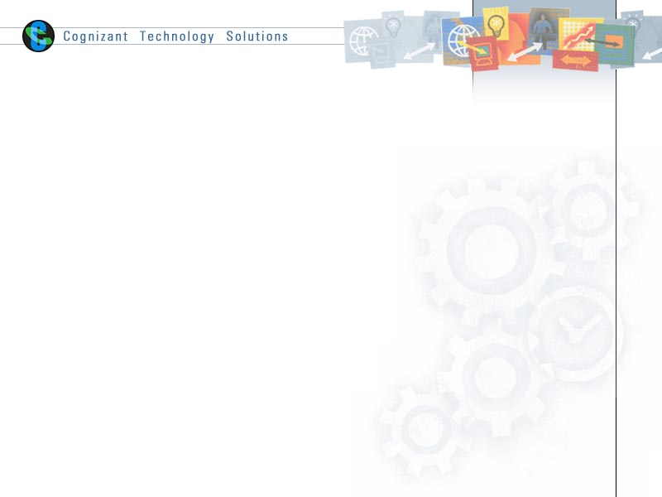

|  |  |  |  |
| --- | --- | --- | --- |
|  | **Prepared By / Last Updated By** | **Reviewed by** | **Approved By** |
| **Name** | ABIRAM R | Snehal Gawari | Snehal Gawari |
| **Role** | Power BI Developer | Architect | Architect |
| **Signature** | ABIRAM R |  |  |
| **Date** | 3/13/2025 |  |  |

**Table of Contents**

**TOPICS**  **PAGE NO**

1 Introduction 3

1.1 Purpose of the document 3

1.2 Definitions and Acronyms 4

2 Data Sources 5

2.1 Data Source Overview 5

2.2 E-R Model 8

3 Report Objective: 9

3.1 Metrics and dimensions list: 9

3.2 Detailed calculation logic for the Metrics 12

4 Reporting Data Model Design 13

5 Report Insight 14

# **1**. **Introduction**

This IPL analysis project harnesses comprehensive data from a multitude of players, teams, and matches to produce detailed and insightful reports. By meticulously examining team performances, player statistics, and match results, the project uncovers significant trends, strengths, and areas needing improvement. These insights are invaluable for refining strategies, benefiting teams, coaches, and analysts alike. The ultimate goal is to leverage this data-driven approach to enhance decision-making processes, optimize performance, and achieve better outcomes in future IPL seasons. Through this thorough analysis, the project aims to provide a competitive edge and foster continuous improvement within the league

## **P****urpose of the document**

The main objective of this project is to deliver a end to end analysis of IPL data using Power BI. We are aiming to convert the raw data of inputs into useful insights with the help of reports and dashboards. The understanding of historical data of players, matches allows us for making better predictions, improved player performance management and a deeper understanding of the dynamics.

The analysis also serves to determine trends in team performances, important match statistics and other vital factors driving game results. These insights can be used by teams to find the strength and weakness of the opponent team during the matches. This report is a data driven decision making that will guide analysts, team strategists and cricket fans by providing an interactive and clear presentation of IPL statistics.

**Pr****erequisites**

* Access to the Power BI
* Knowledge of the business requirements for the report
* Dataset Of IPL from 2008 to 2016

## **1.2 Definitions and Acronyms**

|  |  |
| --- | --- |
| Acronym / Technical Term | Description |
| KPI | Key Performance Indicator |
| PBI | Power BI |
| DAX | Data Analysis Expression |

**KPI:** A KPI, or Key Performance Indicator, is a quantifiable measure used to evaluate the success of an organization, employee, or other entity in meeting objectives for performance. Essentially KPIs help organizations assess their progress in achieving their strategic and operational goals.

**Power BI:** Power BI is a business analytics service provided by Microsoft. It offers interactive visualization tools and business intelligence capabilities with an interface simple enough for end users to create their own reports and dashboards.

**DAX:** DAX, or Data Analysis Expressions, is a formula expression language used in Analysis Services, Power BI, and Power Pivot in Excel. DAX formulas include functions, operators, and values to perform advanced calculations and queries on data in related tables and columns in tabular data models.

# **2. Data Sources**

## **2.1 Data Source Overview**

* **Player Match Table**

This is the fact table of the report which contains

- Match Id

- Player Id

- Team Id

- Is Captain

* **Match Table**

This table contains details about each match such as

- Match Id

- Match Date

- Team Name Id

- Opponent Team Id

- Venue Name

* **Team Table**

This is table contains team information such as

- Team Id

- Team Name

- Team Short Code

* **Season Table**

This table contain details about each season such as

- Season Id

- Season Name

- Orange Cap Id

- Purple Cap Id

* **Player Table**

This table include details about players such as

- Player ID

- Player Name

- Country

* **Batsmen Table**

This table contain details about each batsman such as

- Player Id

- Player Name

- Strike rate

- Country

* **Bowlers Table**

This table include details about bowlers such as

- Player ID

- Player Name

- Economy Rate

- Country

## A diagram of a diagram AI-generated content may be incorrect.E-R Model

# **3. Report Objective:**

## **3.1 Metrics and dimensions list:**

Key Performance Indicators:

**Page 1** **–** **Home** – (Page navigation except Team analysis, Drill through to Team analysis)

1. Team Name

2. Navigation to Overall analysis

3. Navigation to Batsman analysis

4. Navigation to Bowler analysis

5. Team Logos

**Page 2 ­–** **Overall Analysis** (Page navigation to Top Batsman, Top Bowlers and Home)

1. Season Year by Slicer

2. Title winner team, Orange cap Player, Purple cap player, Man of the series, Final match venue

3. Team name, Played, Won, Lost

4. Number of Bowlers by country

5. Win percentage while batting and bowling first

6. Number of Batsman by country

7. Total matches played and won by each team

**Page 3 –** Top **Batsmen** (Page navigation to Overall Analysis, Top Bowlers and Home)

1. Player names by slicer

2. Batsman Name, Photo

3. Age, Balls played, Runs

4. Batting hand, Played teams

5. Strike rate

6. Player country

7. Total matches played by Batsman

**Page 4 –** **Top Bowlers** (Page navigation to Overall Analysis, Top Batsmen and Home)

1. Player names by slicer

2. Bowler Name, Photo

3. Age, Total overs, Runs

4. Batting hand, Played teams

5. Economy rate

6. Player country

7. Total matches played by Bowler

**Page 5 –** **Team Analysis -** (Drill through from Home page)

1. Team name, Team Logo

2. Team’s bowlers name, Wickets, Economy rate and country

3. Total Finals Played

4. Team’s batsmen name, Runs, Strike rate and country

5. Total number of matches played in each venue

6. Matches won, Matches lost (bookmark)

7. Venue based wins

**3.2 Detailed calculation logic for the Metrics**

|  |  |
| --- | --- |
| **KEY PERFORMANCE INDEX(KPI)** | **VISUALIZATION** |
| Title Winner, Orange Cap, Purple Cap, Man of Series, Venue, Player name, Age, Total balls, Runs, Style, Played teams, Total overs, Total wickets, Team name, Total Finals played | Card |
| Number of matches played in each Season by Team, Total Matches played in each season by Batsman and Bowler | Area Chart |
| Batsman by Country | Bar Chart |
| Bowlers by Country | Pie Chart |
| Wins Based on Decision | Donut chart |
| Venue based wins | Tree Map |
| Matches played, Matches lost, Economy rate, Strike rate | Gauge |
| Home wins and Away wins | Funnel |
| Team name, Team stats, Batsmen stats, Bowlers stats, Image | Table |
| Matches played and Matches won | Line Chart |
| Filled map | Map |

# 4. Reporting Data Model Design

# 5. Report Insight



